**PONDICHERRY UNIVERSITY**

**(A CENTRAL UNIVERSITY)**



**DEPARTMENT OF COMPUTER SCIENCE M.C.A – THIRD SEMESTER**

**2021 – 2023**

**IWT RECORD NOTE BOOK**

SUBMITTED BY:

**NAME: MANU NARAYANAN**

**REGISTER NUMBER :21352028**

**MCA**

**HTML**

**Program1: Table**

Source code:

<!DOCTYPE html>

<html>

<head>

<title>Table</title>

</head>

<body>

<table border=2 align="center" width="400">

<th>Country</th>

<th colspan=2>Population (In Crores)</th>

<tr align="right">

<td rowspan=3>INDIA</td>

<td>1998</td>

<td>85</td>

</tr>

<tr align="right">

<td>1999</td>

<td>90</td>

</tr>

<tr align="right">

<td>2000</td>

<td>100</td>

</tr>

<tr align="right">

<td rowspan=3>USA</td>

<td>1998</td>

<td>30</td>

</tr>

<tr align="right">

<td>1999</td>

<td>35</td>

</tr>

<tr align="right">

<td>2000</td>

<td>40</td>

</tr>

<tr align="right">

<td rowspan=3>UK</td>

<td>1998</td>

<td>25</td>

</tr>

<tr align="right">

<td>1999</td>

<td>30</td>

</tr>

<tr align="right">

<td>2000</td>

<td>35</td>

</tr>

</body>

</html>

Output:

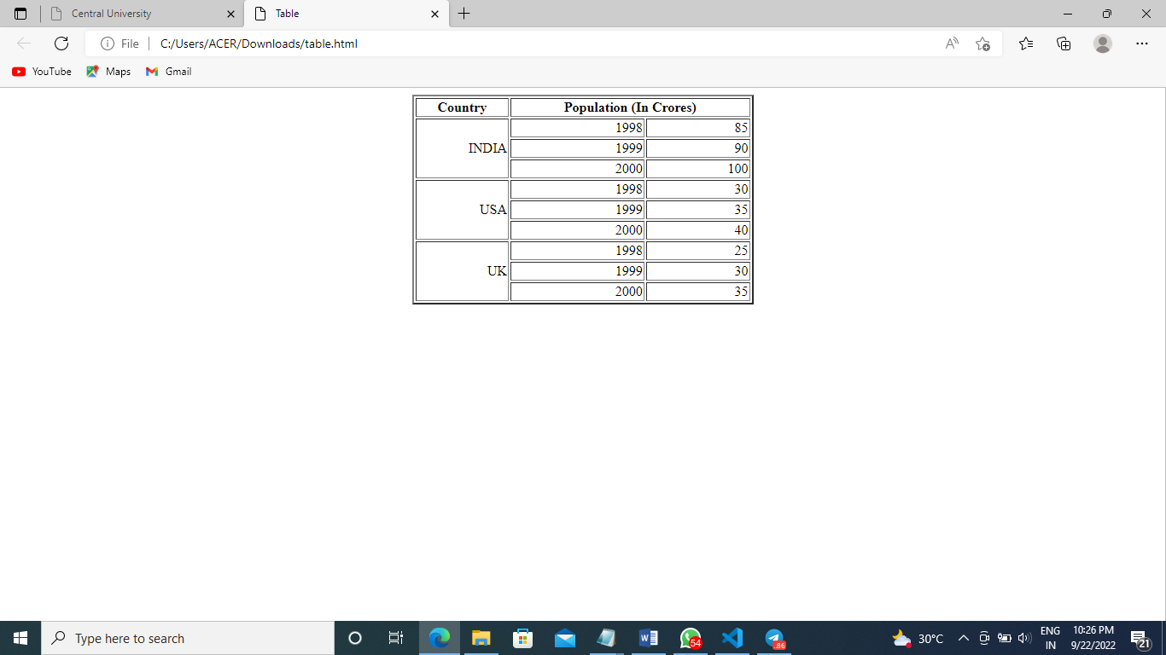

**Program 2: Registration form**

Source code:

<!DOCTYPE html>

<html>

<head>

<title>Registration form</title>

</head>

<body>

<form>

<center><h1>Registration Form</h1>

<table>

<tr>

<td>Username</td>

<td><input type="text" name="usname"></td>

</tr>

<tr>

<td>Password</td>

<td><input type="PASSWORD" name="password"></td>

</tr>

<tr>

<td>Confirm Password</td>

<td><input type="PASSWORD" name="cpassword"></td>

</tr>

<tr>

<td>First Name </td>

<td><input type="text" name="fname" maxlength="20"><br/></td>

</tr>

<tr>

<td>Last Name </td>

<td><input type="text" name="lname" maxlength="20"><br/></td>

</tr>

<tr>

<td>Email</td>

<td><input type="email" name="email"><br/></td>

</tr>

<tr>

<td>Phone Number </td>

<td><input type="NUMBER" name="mobileno" maxlength="10"><br></td>

</tr>

<tr>

<td>Location </td>

<td><input type="text" name="location" maxlength="20"><br/></td>

</tr>

<tr>

<td></td>

<td><input type="submit" name="Save" value="Save" ><input type="submit" name="Reset" value="Reset" ></td>

</tr>

</center>

</form>

</table>

</body>

</html>

Output:

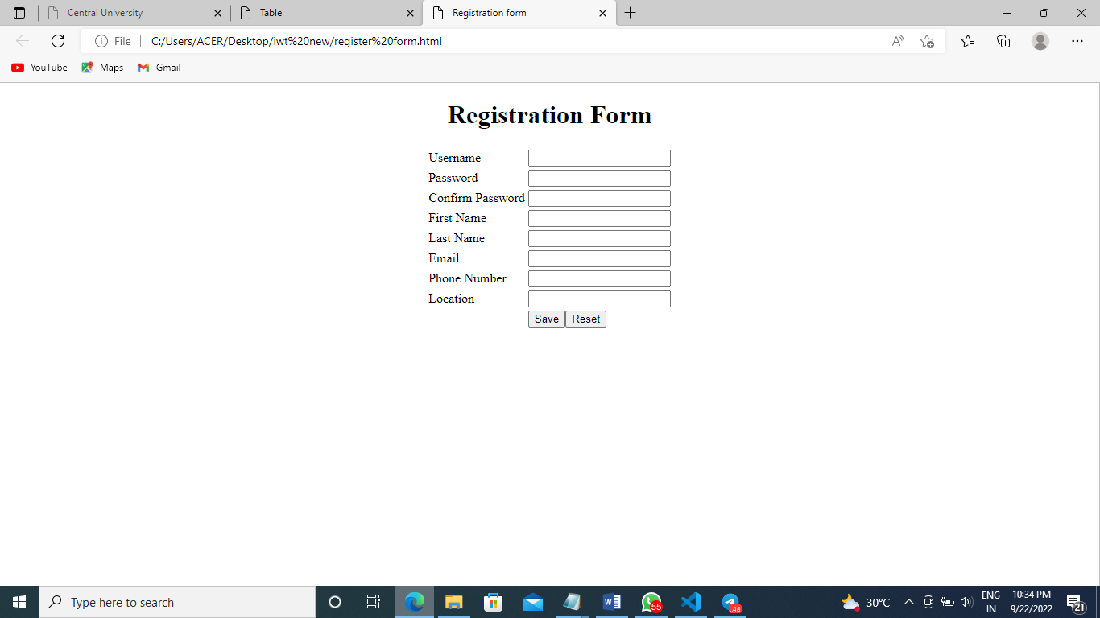

**Program 3: Frame**

Source code:

<!DOCTYPE html>

<html>

<head>

<title>frames</title>

</head>

<frameset rows="30%,*">

<frame src="top.html"></frame>

<frameset cols="*,*">

<frame src="left.html"></frame>

<frame src="right.html"></frame>

</frameset>

</frameset>

</html>

*top.html*

<!DOCTYPE html>

<html>

<head>

<title>Top page</title>

</head>

<body bgcolor="red">

<h2 align="center" style="color: white">Top Frame</h2>

</body>

</html>

*left.html*

<!DOCTYPE html>

<html>

<head>

<title>Left page</title>

</head>

<body bgcolor="orange">

<h2 align="center" style="color: white">Left Frame</h2>

</body>

</html>

*right.html*

<!DOCTYPE html>

<html>

<head>

<title>Right page</title>

</head>

<body bgcolor="orange">

<center>

<h2 style="color: white ;size: 3">Right Frame</h2>

</center>

</body>

</html>

Output:

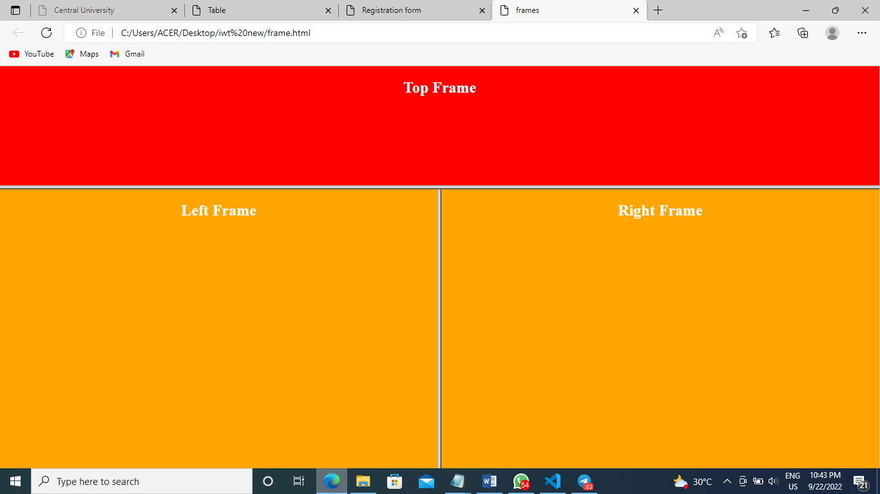

**Program 4: Frames**

Source code:

<!DOCTYPE html>

<html lang="en">

<head>

<meta charset="UTF-8">

<meta http-equiv="X-UA-Compatible" content="IE=edge">

<meta name="viewport" content="width=device-width, initial-scale=1.0">

<title>assgmnt3 A frames</title>

<frameset rows="20%,40%,40%">

<frame src="first.html"/>

<frameset cols="50%,50%">

<frame src="second.html" />

<frame src="third.html"/>

</frameset>

<frameset cols="30%,30%,40%">

<frame src="fourth.html" />

<frame src="fifth.html" />

<frame src="sixth.html" />

</frameset>

</frameset>

</head>

</html>

*first.html*

<!DOCTYPE html>

<html lang="en">

<head>

<meta charset="UTF-8">

<meta http-equiv="X-UA-Compatible" content="IE=edge">

<meta name="viewport" content="width=device-width, initial-scale=1.0">

<title>first frame</title>

</head>

<body bgcolor="orange">

<h3>Manu Narayanan</h3>

<p>Nalamvathukkal House, <br>Udma, Kasaragod

</p>

</body>

</html>

*second.html*

<!DOCTYPE html>

<html lang="en">

<head>

<meta charset="UTF-8">

<meta http-equiv="X-UA-Compatible" content="IE=edge">

<meta name="viewport" content="width=device-width, initial-scale=1.0">

<title>Second frame</title>

</head>

<body bgcolor="bisque">

<ul>

<li>SSLC</li>

<li>Plus Two</li>

<li>Ug- Bsc Computer Science</li>

<li>Pg- Master of Computer Application</li>

</ul>

</body>

</html>

*third.html*

<!DOCTYPE html>

<html lang="en">

<head>

<meta charset="UTF-8">

<meta http-equiv="X-UA-Compatible" content="IE=edge">

<meta name="viewport" content="width=device-width, initial-scale=1.0">

<title>Document</title>

</head>

<body bgcolor="bisque">

<a href="https://www.google.com" target="_blank">google</a>

<br>

<a href="https://www.instagram.com" target="_blank">Instagram</a>

<br>

<a href="https://www.youtube.com" target="_blank">Youtube</a>

</body>

</html>

*fourth.html*

<!DOCTYPE html>

<html lang="en">

<head>

<meta charset="UTF-8">

<meta http-equiv="X-UA-Compatible" content="IE=edge">

<meta name="viewport" content="width=device-width, initial-scale=1.0">

<title>Document</title>

</head>

<body bgcolor="burlywood" style="font-size:30px">

<marquee behavior="scroll" direction="right">Scrolling message : Helloooo</marquee>

</body>

</html>

*fifth.html*

<!DOCTYPE html>

<html lang="en">

<head>

<meta charset="UTF-8">

<meta http-equiv="X-UA-Compatible" content="IE=edge">

<meta name="viewport" content="width=device-width, initial-scale=1.0">

<title>Document</title>

<style>

#blink{

color:blue;

animation: blink 1s linear infinite ;

}

@keyframes blink

{

0%{opacity: 0;}

50%{opacity: .5;}

100%{opacity: 1;}

}

</style>

</head>

<body bgcolor="burlywood">

<p id="blink">Reminder:New notification</p>

</body>

</html>

*sixth.html*

<!DOCTYPE html>

<html lang="en">

<head>

<meta charset="UTF-8">

<meta http-equiv="X-UA-Compatible" content="IE=edge">

<meta name="viewport" content="width=device-width, initial-scale=1.0">

<title>Document</title>

</head>

<body bgcolor="burlywood">

<img src="manu.jpg">

</body>

</html>

Output:

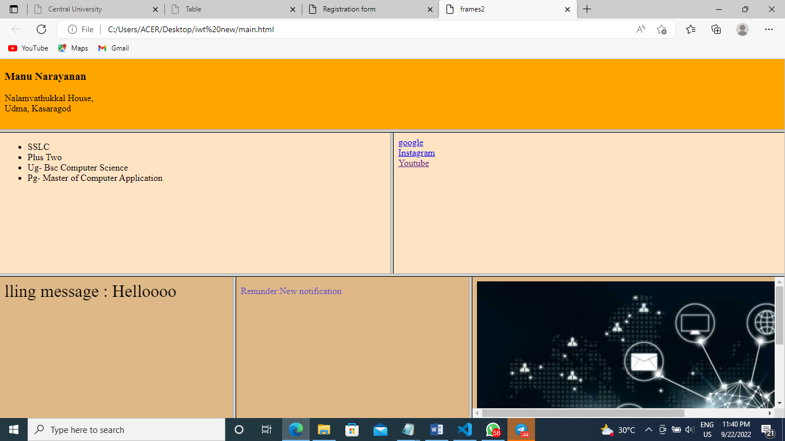

**Program 5: Form**

Source code:

<html>

<head> <title>Assignment2 A</title>

</head>

<br>

<br>

<table border=2 align="center">

<tr>

<td>

<form>

<div>

<label>Enter name of Your friend</label>

<input type="textbox">

</div><br><div>

<label>Chose the file you want to post to your friend</label></div><br>

<div>

<input type="textbox"><input type="file">

</div><br><div>

<label>What does the file contain?</label></div><br><div>

<input type="checkbox"> Image<input type="checkbox"> Source code<input type="checkbox"> Binarycode</div><br><div>

You have completed the form<Button>Submit Query</button>

</div><br>

</td>

</tr>

</table>

</form>

</body>

</html>

Output:

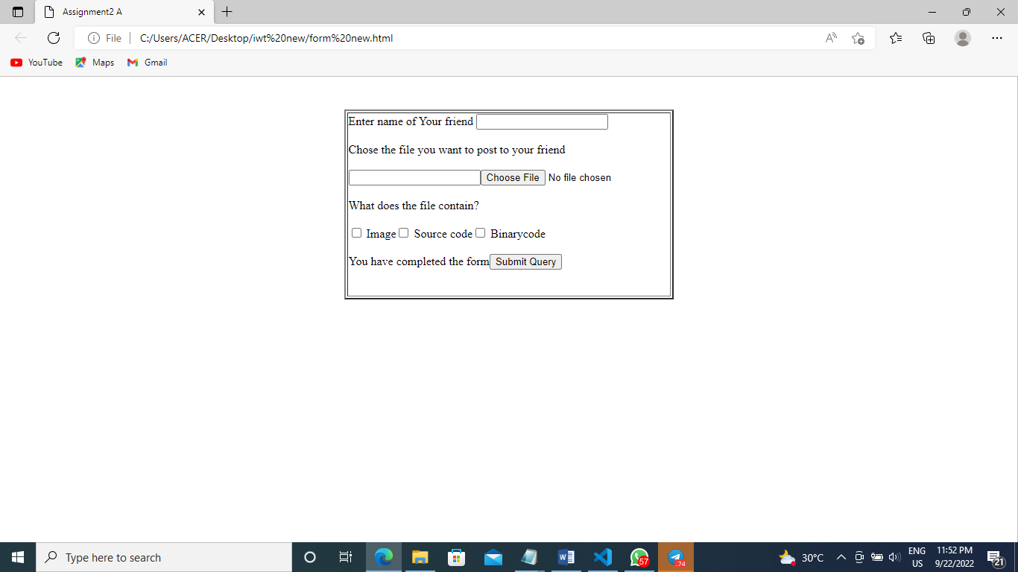

**CSS**

**CSS1:**

Source code:

<!DOCTYPE html>

<html>

<head>

<title>pondi uni</title>

<link rel="stylesheet"href="new css.css">

</head>

<body id="grad1">

<div>

<ul>

<li><a href="https://www.pondiuni.edu.in/home/">Home</a></li>

<li><a href="#news">News</a></li>

<li><a href="#contact">Contact</a></li>

<li style="float:right"><a class="active" href="#about">About</a></li>

</ul>

</div>

<br>

<center><h1>welcome</h1></center>

<center><p> Pondicherry University, also known as PU, is a collegiate public central university located in Kalapet, Pondicherry, Union Territory of Puducherry</p>

</center>

<center>

<div class="gallery">

<a target="_blank" href="sj.jpg">

<img src="sj.jpg" alt="sj" width="600" height="400">

</a>

<div class="desc">Silver Jubilee campus</div>

</div>

<div class="gallery">

<a target="_blank" href="green.png">

<img src="green.png" alt="green" width="600" height="400">

</a>

<div class="desc">Madanjeet School of Green Energy Technologies</div>

</div>

<div class="gallery">

<a target="_blank" href="social.jpg">

<img src="social.jpg" alt="s" width="600" height="400">

</a>

<div class="desc">School of Social science</div>

</div>

<div class="gallery">

<a target="_blank" href="dist.jpg">

<img src="dist.jpg" alt="dist" width="600" height="400">

</a>

<div class="desc">Directorate of Distance Education</div>

</div>

<div class="gallery">

<a target="_blank" href="hum.jpg">

<img src="hum.jpg" alt="hum" width="600" height="400">

</a>

<div class="desc">School of Humanities</div>

</div>

<div class="gallery">

<a target="_blank" href="phy.jpg">

<img src="phy.jpg" alt="phy" width="600" height="400">

</a>

<div class="desc">Department of Physics</div>

</div>

</center>

</div><br><br><br><br><br><br><br><br><br><br><br>

<h4>Admission:<a href="https://www.pondiuni.edu.in/admissions-2022-23/">Click Here.</a><br></h4>

<h4>Schools:<a href="https://www.pondiuni.edu.in/admissions-2022-23/">Click Here.</a><br></h4>

</body>

</html>

**css code:**

#grad1 {

height: 700px;

background-color: red; /* For browsers that do not support gradients */

background-image: linear-gradient(to bottom right, #ff00ff, #00ffff);

}

h1{

text-shadow: 0 0 5px #99ff33, 0 0 5px #ff66ff;

}

div.gallery {

margin: 5px;

border: 1px solid #ccc;

float: left;

width: 180px;

}

div.gallery:hover {

border: 1px solid #777;

}

div.gallery img {

width: 100%;

height: auto;

}

div.desc {

padding: 15px;

text-align: center;

}

ul {

list-style-type: none;

margin: 0;

padding: 0;

overflow: hidden;

background-color: #333;

}

li {

float: left;

}

li a {

display: block;

color: white;

text-align: center;

padding: 14px 16px;

text-decoration: none;

}

li a:hover:not(.active) {

background-color: #111;

}

.active {

background-color: #04AA6D;

}

Output:

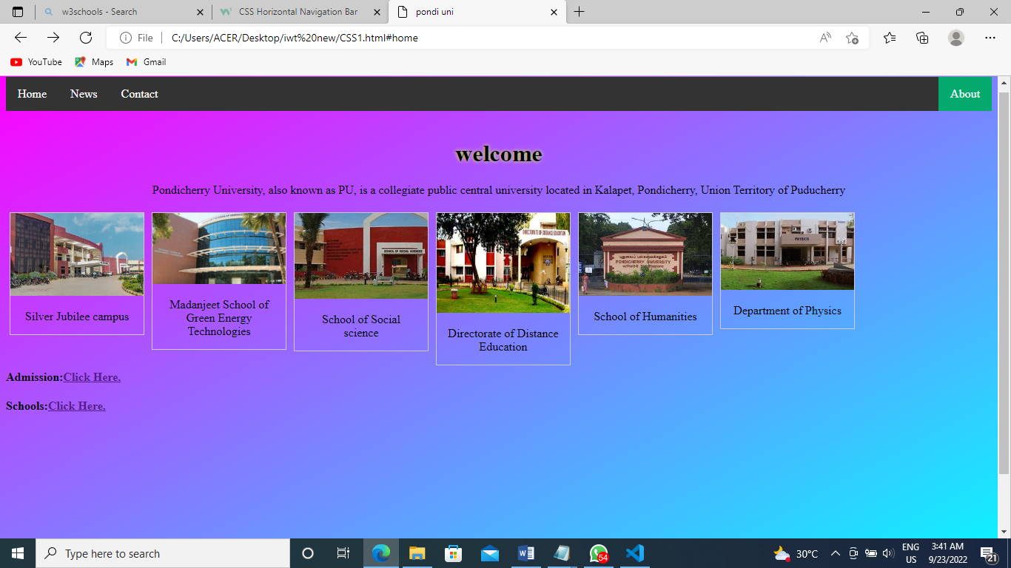

**CSS2**

Source code:

<!DOCTYPE html>

<html>

<head>

<link rel="stylesheet" href="animcss.css">

</head>

<body>

<div>

<center><img src="1.jpg" alt="Paris" style="width:150px"></center>

<p>Cristiano Ronaldo dos Santos Aveiro GOIH ComM is a Portuguese professional footballer who plays as a forward for Premier League club Manchester United and captains the Portugal national team. </p>

</div>

</body>

</html>

Css code:

body {

margin: 0;

padding: 0;

display: flex;

justify-content: center;

align-items: center;

height: 100vh;

background-color: #000;

}

img {

border: 1px solid #ddd;

border-radius: 4px;

padding: 10px;

width: 150px;

}

p {

position: relative;

font-family: sans-serif;

text-transform: uppercase;

font-size: 2em;

letter-spacing: 4px;

overflow: hidden;

background: linear-gradient(90deg, #000, #fff, #000);

background-repeat: no-repeat;

background-size: 80%;

animation: animate 5s linear infinite;

-webkit-background-clip: text;

-webkit-text-fill-color: rgba(255, 255, 255, 0);

}

@keyframes animate {

0% {

background-position: -500%;

}

100% {

background-position: 500%;

}

}

Output:

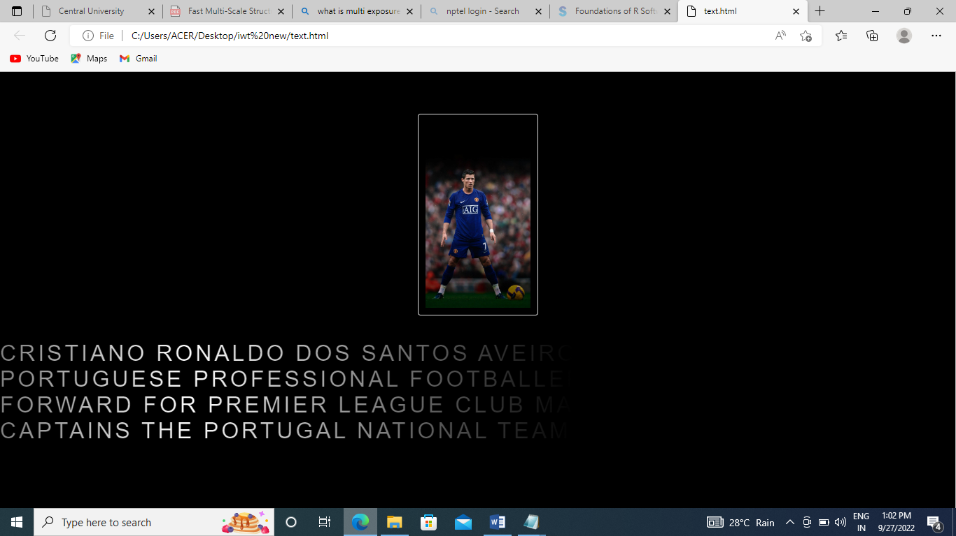

**CSS3**

Source code:

<!DOCTYPE html>

<html>

<head>

<link rel="stylesheet" href="cssbg.css">

</head>

<body>

<h2>Computer</h2>

<div class="ex1">A computer is a digital electronic machine that can be programmed to carry out sequences of arithmetic or logical operations (computation) automatically. Modern computers can perform generic sets of operations known as programs. These programs enable computers to perform a wide range of tasks.</div><br>

<div class="ex2">Charles Babbage, an English mechanical engineer and polymath, originated the concept of a programmable computer. Considered the "father of the computer.</div><br>

<div class="ex3">During the first half of the 20th century, many scientific computing needs were met by increasingly sophisticated analog computers, which used a direct mechanical or electrical model of the problem as a basis for computation. However, these were not programmable and generally lacked the versatility and accuracy of modern digital computers.</div><br>

<div class="ex4">The principle of the modern computer was proposed by Alan Turing in his seminal 1936 paper,[42] On Computable Numbers. Turing proposed a simple device that he called "Universal Computing machine" and that is now known as a universal Turing machine. He proved that such a machine is capable of computing anything that is computable by executing instructions (program) stored on tape, allowing the machine to be programmable.</div>

</body>

</html>

Css code:

body {

background-image: url("00.jpg");

background-color: #cccccc;

height: 500px;

background-position: center;

background-repeat: no-repeat;

background-size: cover;

position: relative;

}

header h1 {

font-size: 70px;

font-weight: 600;

background-image: linear-gradient(to left, #553c9a, #b393d3);

color: transparent;

background-clip: text;

-webkit-background-clip: text;

}

div.ex1 {

background-color: lightgreen;

border: 2px solid black;

padding: 15px;

}

div.ex2 {

background-color: red;

border: 2px solid black;

padding: 15px;

}

div.ex3 {

background-color: lightblue;

border: 2px solid black;

padding: 15px;

}

div.ex4 {

background-color: navajowhite;

border: 2px solid black;

padding: 15px;

}

Output:

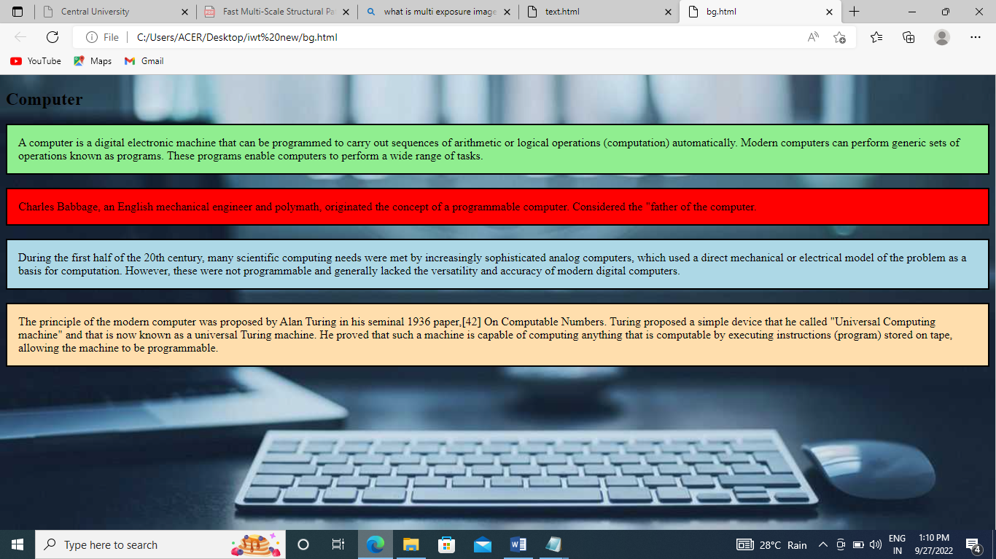

**CSS4**

Source code:

<!DOCTYPE html>

<html>

<head>

<title>

CSS transition opacity

</title>

<link rel="stylesheet" href="trans.css">

<style>

</style>

</head>

<body>

<h1> Use of Transition Opacity Property in CSS </h1>

<div class="pr">

<div class="cr">

Manu Narayanan , MCA

Pondicherry University

</div>

</div>

<p> Move the cursor over the green square box </p>

</body>

</html>

Css code:

.pr{

width: 400px;

height: 300px;

background: blue;

position: relative;

}

.cr{

width: 270px;

height: 200px;

position: absolute;

top: 30px;

left: 30px;

color: black;

margin: 40px auto;

margin-bottom: 30px;

font-family: Arial, Helvetica, sans-serif;

background: pink;

font-weight: Bold;

font-size: 36px;

opacity: 0;

}

.cr:hover {

opacity: 1;

transition: opacity 2s ease-out;

-webkit-transition: opacity 2s ease-out;

-moz-transition: opacity 2s ease-in-out;

}

Output:

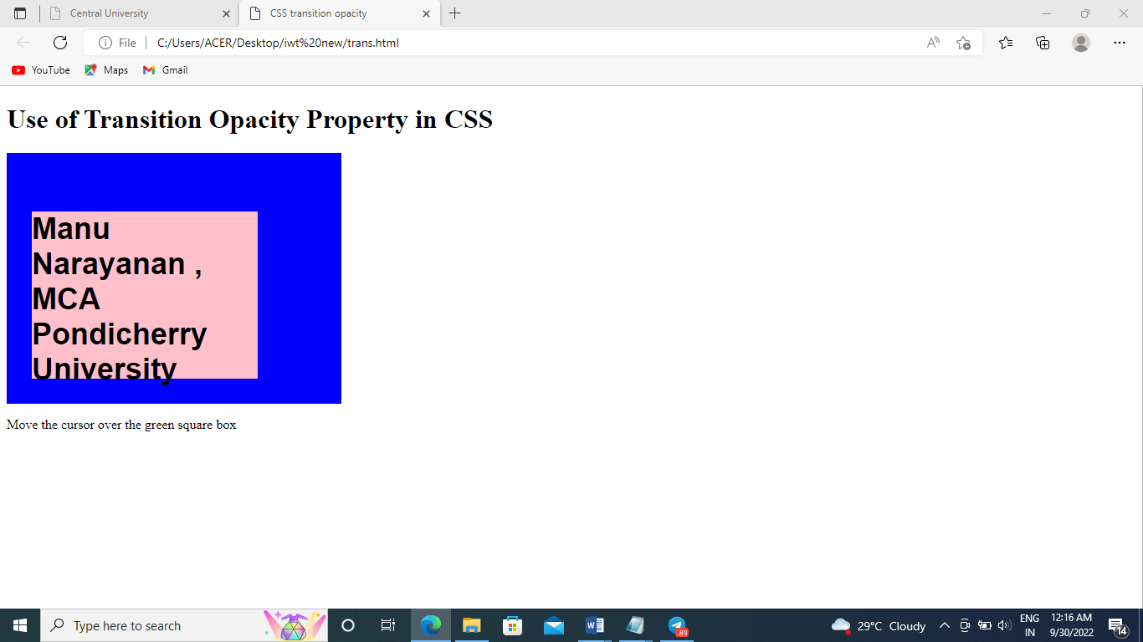

**CSS5**

Source code:

<html>

<head>

<link rel="stylesheet" href="css5.css">

</head>

<body>

<h2>Dropdown Image and Dropdown menu</h2>

<p>Move the mouse over the image and button</p>

<div class="dropdown">

<img src="7.jpg" alt="Cinque Terre" width="150" height="150">

<div class="dropdown-content">

<img src="7.jpg" alt="Cinque Terre" width="450" height="400">

<div class="desc">Cristiano Ronaldoo</div>

</div>

</div>

<div class="dropdown">

<button class="dropbtn">Skill Videos</button>

<div class="dropdown-content">

<a href="https://youtu.be/bdPvE4QpgqM">Link 1</a>

<a href="https://youtu.be/HvQ1WrN6AP4">Link 2</a>

<a href="https://youtu.be/NR6HEUYZXbE">Link 3</a>

</div>

</div>

</body>

</html>

Css code:

.dropdown {

position: relative;

display: inline-block;

}

.dropdown-content {

display: none;

position: absolute;

background-color: #f9f9f9;

min-width: 160px;

box-shadow: 0px 8px 16px 0px rgba(0,0,0,0.2);

z-index: 1;

}

.dropdown:hover .dropdown-content {

display: block;

}

.desc {

padding: 15px;

text-align: center;

}

.dropbtn {

background-color: #4CAF50;

color: white;

padding: 16px;

font-size: 16px;

border: none;

cursor: pointer;

}

.dropdown {

position: relative;

display: inline-block;

}

.dropdown-content {

display: none;

position: absolute;

background-color: #f9f9f9;

min-width: 160px;

box-shadow: 0px 8px 16px 0px rgba(0,0,0,0.2);

z-index: 1;

}

.dropdown-content a {

color: black;

padding: 12px 16px;

text-decoration: none;

display: block;

}

.dropdown-content a:hover {background-color: #f1f1f1}

.dropdown:hover .dropdown-content {

display: block;

}

.dropdown:hover .dropbtn {

background-color: #3e8e41;

}

Output:

